Department of Science & Technology
Details of Technology Development & Transfer from DST supported Projects/Activities
Division: SEED
Name of Scheme/Programme: Core Support
Total Fund support by (i) DST: (ii) Industry (if Any): Nil
Name & Address of PI/Co-PI: Bhopinder Mehta

- Title of Technology / Product developed: Development of Low calorie Amaranthus Biscuits
- Brief write-up: (1/2 page): Keeping in view the prevalence of diseases like diabetes and obesity we have been working on low energy foods using stevia powder(Natural plant sweetener). So we have developed Biscuits using amaranthus & whole wheat flour and stevia powder as sweetener. These have been subjected to sensory analysis over a storage period of 6 months & found satisfactory after storage for 6 months. Nutritional study was carried out at CFTRI, Mysore. It was found that Total Reducing Sugar (TRS=6.2%) & Non-Reducing Sugars (sucrose= 2.0%) level in low calorie biscuit are very-very less as compared to standard amaranthus biscuits, where its levels are 29.8 % & 25.7 % respectively. Also in low calorie biscuits, other desired functional parameters such as total ash, protein, crude fiber, K & P are also higher & un-desired parameters (fats, carbohydrates & calorific value) are lower than in standard amaranthus biscuits.

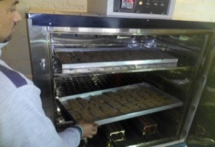
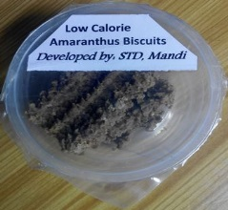
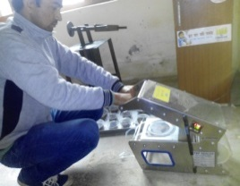
- Details (including Photographs etc.): Biscuits are the most popular bakery items because of their high nutritive value, ready-to-eat nature, and easy availability in different shapes and sizes at an affordable cost. Here idea was to formulate a functional biscuit containing valuable nutrients from traditional millets in addition to reduced sugar calories. Incorporation of amaranthus flour increases the nutritional profile of the products as they are a rich source of proteins, dietary fiber & trace minerals. Due to prevalence of diseases like diabetes and obesity, the use of artificial sweeteners as a sucrose substitutes for the development of low-calorie products has been the focus of R&D in the recent past. But now a day these are being discouraged because of suspicion that they may have some harmful side effects. So keeping in view the above facts we tried Stevia powder (Steviol Glycosides) in place of sugar which have zero calories and do not raise blood glucose level. Thus biscuits have been developed using amaranthus & whole wheat flour and stevia powder as sweetener. These have been subjected to sensory analysis over a storage period of 6 months & found satisfactory after storage for 6 months. Nutritional study was carried out at CFTRI, Mysore. It was found that Total Reducing Sugar (TRS=6.2%) & Non-Reducing Sugars (sucrose= 2.0%) level in low calorie biscuit are very-very less as compared to standard amaranthus biscuits, where its levels are 29.8 % & 25.7 % respectively. Also in low calorie biscuits, other desired functional parameters such as total ash, protein, crude fiber, K & P are also higher & un-desired parameters (fats, carbohydrates & calorific value) are lower than in standard amaranthus biscuits.
- Transferred to Industry: Yes. FARMERS group (Society for Farmers Development, Vill. Talhar, P.O. Nagwain, Teh. Aut, distt. Mandi (H.P.)
- Institutions involved in the project: CFTRI, Mysore for Nutritional analysis of product.
- Stage of development (Tech Transfer, Demonstration, field trial, etc. in next 6-12 months) Approximate Technology Readyness Level (TRL): Ready for demonstration & transfer.
- Further development required (If same group can do it or industry partner is required to get the product/technology in a final form suitable for commercialization: For up-scaling on larger scale & improved packing investment is required.
- Comparison with available technologies: No such type of low calorie biscuits is available in the market.
- Approximate cost/ Economics (for the user e.g. buy-back period): Rs. 40/70 gm pack
- Contact Persons for further details: Bhopinder Mehta, Mob. No. 94598-73461

