Department of Science & Technology
Details of Technology Development & Transfer from DST supported Projects/Activities
Division: SEED
Name of Scheme/Programme: DST-RC Core support project
Total Fund support by (i) DST: (ii) Industry (if Any): Nil
Name & Address of PI/Co-PI/ Contact person: Salma Alavi, Rural Communes,
70, 2nd floor LIC Building, Anandilal Poddar Marg,
Mumbai 400 002
Email: ruralcommunes@gmail.com
Title of Technology: Vertical Bag Agriculture
Product Status: Field Tested and disseminated to small & marginal farmers, women and landless families of rural areas
- Brief write-up (1/2 page):
Developing countries like India is witness to malnutrition and Vitamin deficiency in Children living in villages and children from tribal community. This is due to lack of proper diet. Vegetables are seldom a part of their diet and are eaten once a week or once in a month. It may be due to various reasons such as their economic condition, availability of market place, availability of transport if the village is in remote place or even topographical conditions.
Due to occurrence of malnutrition in the children of such villages, Government has taken up an initiative of “Midday meal”. But the Children do not have access to similar diet in their homes. To compensate these gaps it is essential to introduce “Back yard vertical sack garden agriculture” for those who are landless or small and marginal farmers. This method can be useful for the schools, hostels as well as individual homes in order to provide proper diet.

Vertical vegetable sack garden
Vertical vegetable sack garden is nothing but the cultivation of the vegetables and even medicinal plants for daily use grown in the sack in vertical arrangement.

Procedure for preparation of Sack garden:
- Selection of site for sack garden is essential. The selected place should be close to the house so that it is easy to monitor.
- The site should be thoroughly clean to avoid any insect infestation or diseases. It should be easy to roam around the Bags as it will enable the maintenance of the garden easily.
- The uneven land should be flattened so that the sacks will stay upright and not fall over.
- Soil mixture is prepared by adding soil, properly decomposed cow dung manure, wood ash, rice husk and fine sand in 5:3:1:1:1 ratio. The soil mixture should be sundried at least for a day.
- Green manure should be to the above prepared mixture in 3:1 proportion.
- The sack should be placed on the flattened area then a layer of soil mixture should be prepared of around 2 inches evenly at the bottom.
- Then place the pipe (size min 2.5 inches and according to the size of the sack) in the centre of the sack and pour small pebbles and granules inside the pipe.
- The prepared soil mixture is poured all around the pipe evenly.
- Slowly remove the pipe so that it will form a column of the pebbles and granules.
- Water the prepared soil mixture in the sack with the help of a bucket.
- Once the soil is wet plant the saplings in zigzag pattern as shown in the picture. Keep in mind that while planting the saplings no plant should come directly below each other in the same line.
- 60 cm x 70 cm distance is maintained in between the sacks.
- Water the sacks in the middle column of pebbles (It facilitates the even spread of water throughout the sack) every 3 to 4 days or if soil looks dry.
- After the saplings get stronger and get acclimatised to the sack environment water the sacks in the pebble column at every 2 days interval.

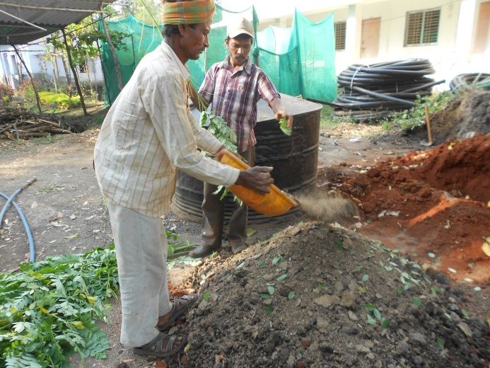  Preparation of soil mixture | 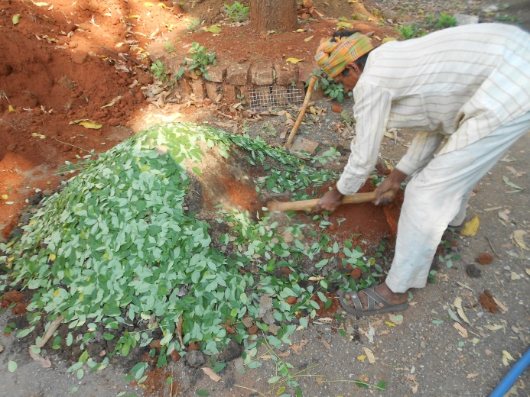  Adding Green Manure
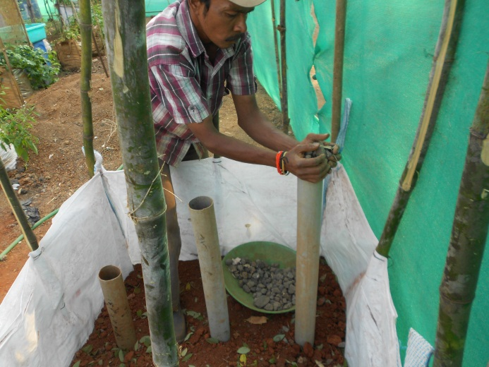  Pipe placed in the centre of the sack to pour pebbles and granules | 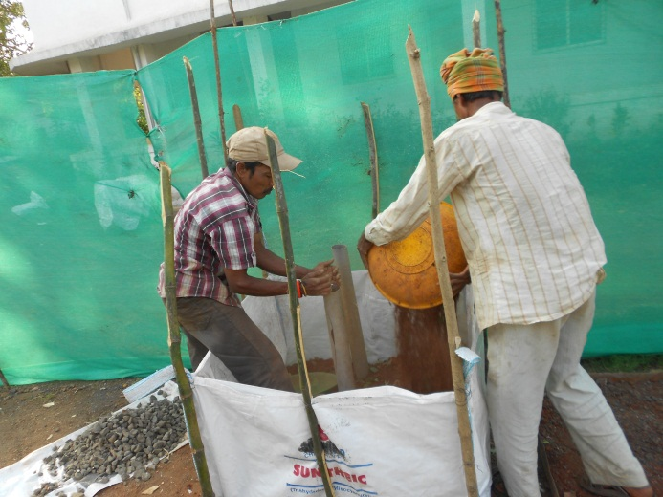  Soil mixture poured around the pipe
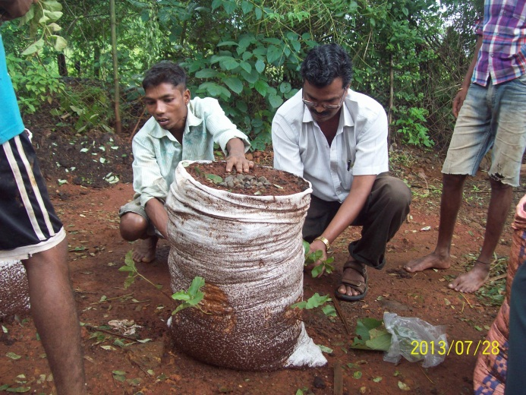  Sapling planted in Zigzag Pattern | 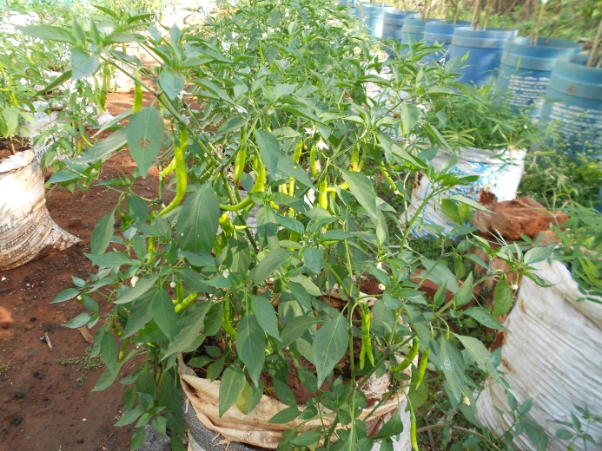  Chilli in Vertical Bag Agriculture
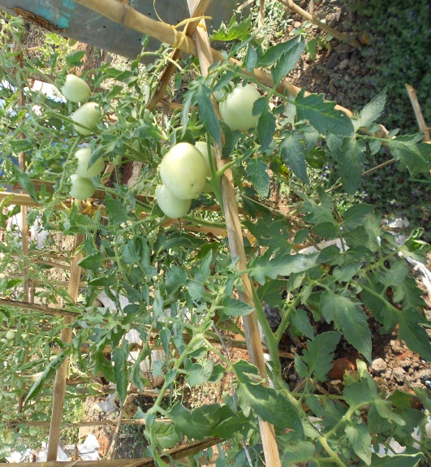  Tomatoes in Vertical Bag Agriculture | 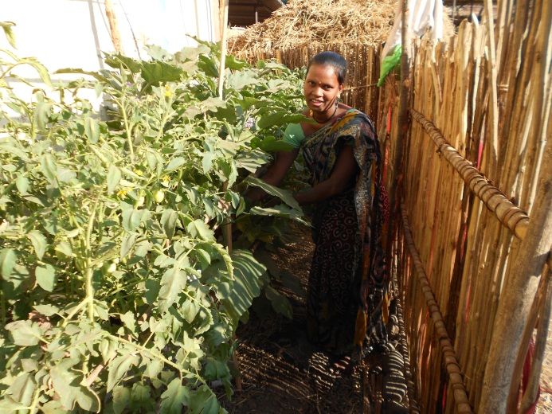  Vertical Bag Agriculture at household level

- Transferred to Industry (if Yes, Name & Address of the Industry):
Technology has been developed and field tested by Rural Communes at our own Training Campus. After the successful demonstration this technology has been demonstrated and disseminated to small & marginal farmers, women and landless families in Rural Communes’ Project areas as well as disseminated at Schools and Ashram Shalas.

- Institutions/ Industries involved in the project:
With active support of Tata Power Community Development Trust, JSW Steel Ltd., ICRISAT and SEED Division, Department of Science and Technology we are able to disseminate this innovative idea to the rural communities.

- Stage of development (Tech Transfer, Demonstration, field trial, etc.in next 6-12 months) Approximate Technology Readyness Level (TRL):TRL – Field tested, demonstrated and disseminated among small & marginal farmers, women, landless, Zilla Parishad Schools and Ashram Shalas

- Further development required (If same group can do it or industry partner is required to get the product/technology in a final form suitable for commercialisation:

No further development required as RC started this activity in 2013 and after the successful field trial, need based technology has been added and successfully demonstrated and disseminated to household and schools.

- Comparison with available technologies:
Small & Marginal Farmers including landless families have a very small plot of land at their backyard or around their homes. They generally do direct plantation on the plot without following any step process / intensification systems due to which the yield is very low. To enhance their income and livelihood security and to address supplementary nutrition, Rural Communes introduced and promoted Vertical Bag Agriculture. We have trained farmers & landless to follow the step process i.e. organic soil preparation, water management, weed and pest management and multiple mix plantation in one bag. This helps in getting high yield and organic food at household level. In the area of 1 gunta 250 plants can be seeded and in the same area of land 250 vertical bags can be set up where each bag contains 7-8 plants i.e. total 1750 plants.

- Approximate cost/ Economics (for the user e.g. buy-back period):
Approximate cost for one bag (same bag can be used for 2 years)
Sr. | Require material | Quantity | Expenditure (Rs)
1 | Sack - standard size – 60X 90 cm, capacity of carrying weight – 30 kg ( waste sack can be select and reuse) | 1 No | 10
2 | Soil Mixture ( Prefer Red soil) | 35 kg | 25
3 | Cow dung compost / Farm Yard Manure | 6 kg | 30
4 | Ash from burnt wood | 2 kg | 20
5 | Small pebble/ granules ( ½ inches) | 5 kg | 25
6 | Fine sand | 1 kg | 10
7 | Rice husk | 2 kg | 20
8 | Green manure (Leaves of Gliricidia/ Nirgudi/ Karanj) | 3 kg | 15
9 | Plants (Chilli/ Tomato/ brinjal,etc.) | 9 | 18
10 | Labour charges | 1 hr | 40
11 | Pesticide (bio-pesticide like dashparni ark or neem ark) |  | 150
 | Total |  | 363

- Contact Persons for further details:
Rural Communes
70, 2nd Floor, LIC Building
Anandilal Poddar Marg
Mumbai 400 002
Tel: 022-22085601 / 22050426
Email: ruralcommunes@gmail.com

