Department of Science & Technology
Details of Technology Development & Transfer from DST supported Projects/Activities
Division: SEED
Name of Scheme/Programme: DST-RC Core support project
Total Fund support by (i) DST: (ii) Industry (if Any): Nil
Name & Address of PI/Co-PI/ Contact person: Salma Alavi, Rural Communes,
70, 2nd floor LIC Building, Anandilal Poddar Marg,
Mumbai 400 002
Email: ruralcommunes@gmail.com
Title of Technology: Alternative Analytical Technology (AAT) for Soil Nutrient analysis through image processing Chromatograms

Product Status: Soil Testing Lab installed at our Centre for Experiential Learning, Rural Communes Training Campus and successful trial of soil testing has been done.

Installed digital soil testing lab for understanding of soil nutrients requirement as per crop in a short period of time

- Brief write-up (1/2 page):
High crop yields cannot be obtained unless the farmers overcome existing deficiencies by applying sufficient fertilizers. In using a fertilizer he must take into account the requirement of his crops and the characteristics of the soil. Farmers, however, find it extremely difficult to choose the proper type of fertilizer to match his soil. The basic objective of the soil-testing is, therefore to give farmers a service that will give them a comprehensive soil profile of their land. This will lead to better and more economic use of fertilizers and better soil management practices thereby helping them to increase their agricultural production. .Efficient use of fertilizers is a major factor in any agricultural activities to bring about an economic increase in agricultural production.

Right kind of fertilizer Right dose of Fertiliser application is important for maintaining soil health

Soil testing and analysis requires four steps:
- Collection of soil sample following appropriate method
- Preparation of solutions.
- Image preparation.
- Image/Software analysis.

The process involves
Mixing of Soil in alkali solution
Digestion of soil solution
Incubation at static condition
Spreading of photo reactive substance on Whatman No.1 filter paper (WFP)
Drying of filter paper under dark condition
Spreading of Soil alkali extracts in the WFP
Drying of filter paper completely
Image Development
Image scanning, Image processing and Case base reasoning
Printing soil test report
Getting advice on suitable crop and fertilizer application
Equipment and materials required
Equipments
- Filter paper marking device (Indigenous fabrication)
- Chromatogram boxes
- Drying table (Indigenous fabrication)
- Micropipette 1ml and 5ml
Glasswares & Lab Materials
- Weighing balance
- Conical flask (250ml capacity)
- Watch glass
- Plastic Trays (3 nos), beaker (5 litre-1no), measuring cylinder (100ml-1no)
Computer Hardware
- Computer (2GB RAM, 320 GB hard disk capacity)
- Printer and Scanner (HP or Canon)

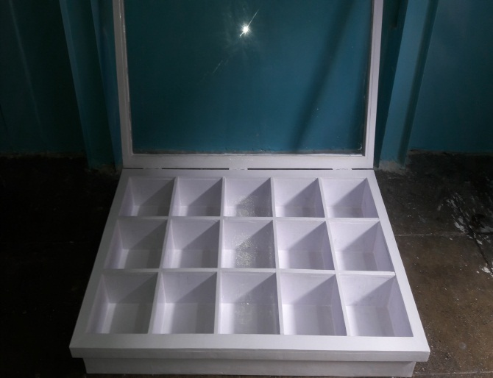  Chromatogram Box | 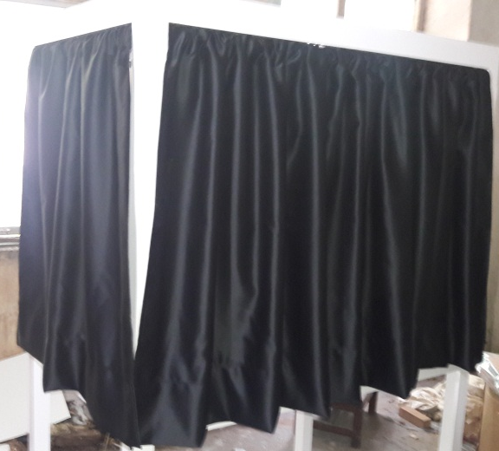  Drying Table
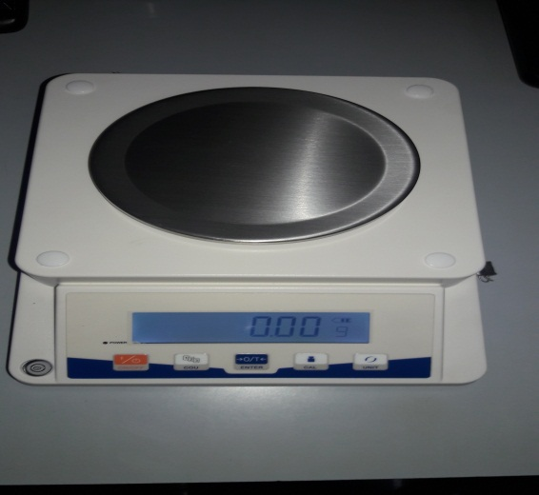  Weighing Machine | 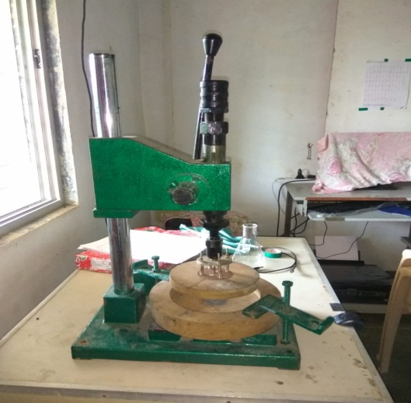  Filter Paper Marking Device
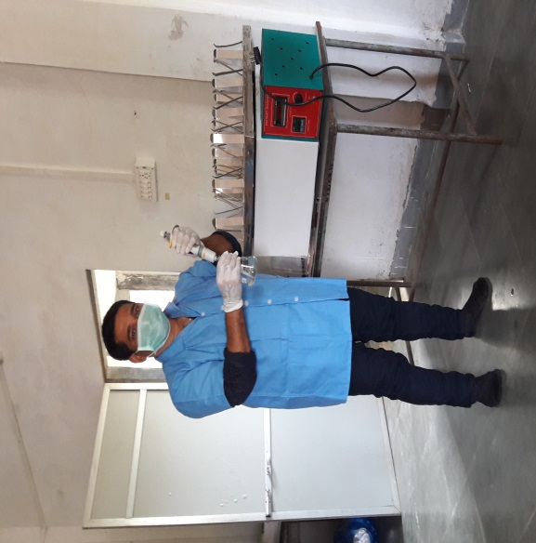  Soil Testing at our Training Campus | 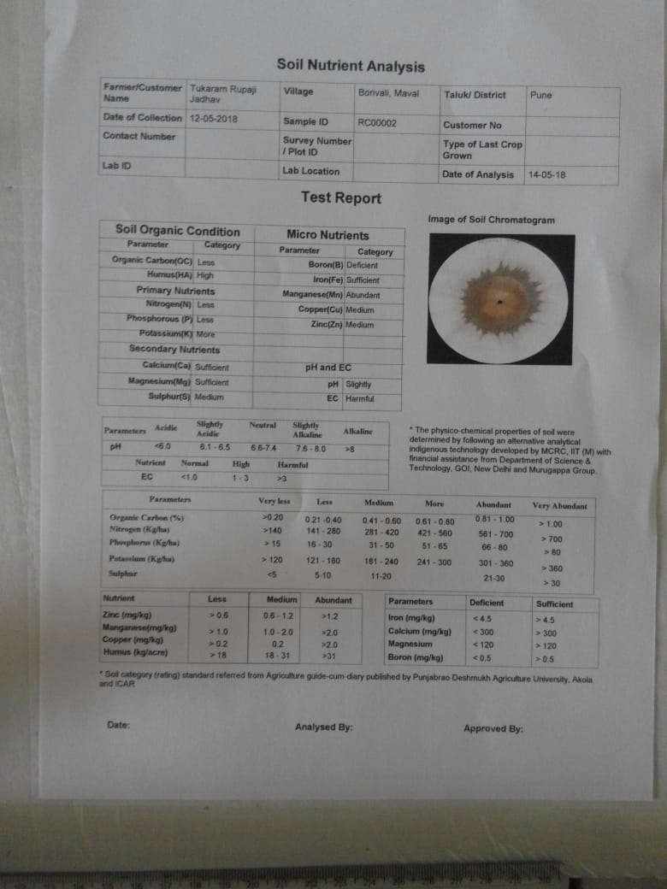  Sample Report

- Transferred to Industry (if Yes, Name & Address of the Industry):
Technology has been developed by Shri AMM Murugappa Chettiar Research Centre (MCRC), Chennai and adopted by Rural Communes. With the help of MCRC Experts /Official, the Soil Testing Lab has been set up at our Rural Communes Training Campus, Centre for Experiential Learning. Training was given to our Core Team and Field Staff by MCRC. We are now successfully conducting soil testing for our target farmers.

- Institutions/ Industries involved in the project:
Shri AMM MurugappaChettiar Research Centre (MCRC), Chennai

- Stage of development (Tech Transfer, Demonstration, field trial, etc. in next 6-12 months) Approximate Technology Readyness Level (TRL):TRL – Set up the soil testing lab at Rural Communes Training Campus and soil sample testing has been successfully done. Now the soil testing of our target farmers is on-going

- Further development required (If same group can do it or industry partner is required to get the product/technology in a final form suitable for commercialisation:

No further development required.

- Comparison with available technologies:
Compared to existing technologies the MCRC Soil Testing Technology is very cost effective, simple and reliable. It helps determine the level of organic carbon, humus, nitrogen, phosphorous, potassium and micronutrients (10) in soil so as to provide the farmer with information he requires to maintain the health of the soil. Through this technology we can get crop wise fertiliser recommendation and the process of soil testing can be completed within two days.
As per the information collected from various sources it was found that the cost for testing a single soil sample could vary between Rs. 250 to Rs. 1250 at a Soil Testing Lab run by Government or other agencies and besides the farmers have to follow a very lengthy procedure for carrying out soil testing.

- Approximate cost/ Economics (for the user e.g. buy-back period):
Approximate cost for setting up soil testing lab would be Rs.2,00,000/-.

- Contact Persons for further details:
For Field Trial
Name:
Rural Communes
70, 2nd Floor, LIC Building
AnandilalPoddarMarg
Mumbai 400 002
Tel: 022-22085601 / 22050426
Email: ruralcommunes@gmail.com

For Technical
Shri AMM Murugappa Chettiar Research Centre,
Taramani, Chennai 600 113.

