Panchagavya - as a liquid formulation
Chemical fertilizers, pesticides and weedicides are becoming very costly and create lot of problems for soil, environment, humans and livestock. So the world is moving towards sustainable farming and organic farming with the help of organic manure, bio manure and bio pest control agents.,
Liquid bio formulations, a promising component for organic farming with multiple benefits as it acts as a growth promoter and pest repellent. It is usually produced from agro waste, cow urine leaf extract etc., and hence it can be prepared by the farmer at very low cost in the farm itself. Bio-formulations are prepared from the basic component of cow dung and cow urine etc.,
The basic component act as a dispersal medium and transmitting agents. It also provides Nano-cellulose particles for attachment and multiplication of microorganisms. The formulation is usually fermented for 7 days - 20 days, so that little amount of Alcohol is also produced which often act as an intercellular transmission agent for dissolved nutrients already in the formulations.
During the fermentation and incubation, a variety of beneficial microorganisms establishes in the medium and got immobilized in the cellulose Nano – particles in the formulations.
Required Items:
Biogas slurry - 10 litres
Cow’s urine - 3 litres
Cow’s milk - 2 litres
Curd - 2 litres
Cow’s ghee - 1 kg
Sugar cane juice - 2 litres
Banana fruit - 12 nos.
Tender coconut water - 3 litres
Toddy - 2 litres
Yeast powder - 200 grams
Procedure:
1. Take a fresh plastic can or mud pot. Mix 1 kg cow ghee with 5 kg of fresh Cow dung slurry and keep it for 3 days.
2. Stir this mixture twice a day.
3. On 4th day, add the other items with the above mixture.
4. Stir it twice a day for 15 days.
5. On 16th day filter the content with a muslin cloth and the filtrate is “Panchagavya” ready for field application.
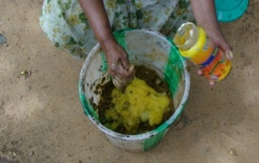
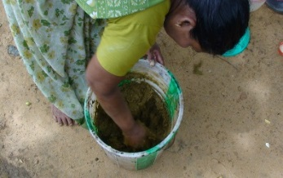
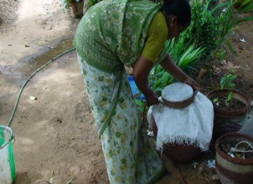
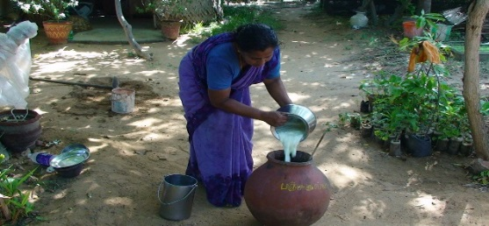
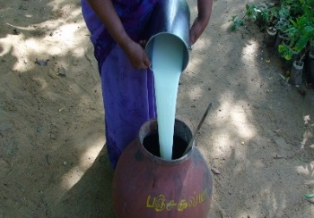
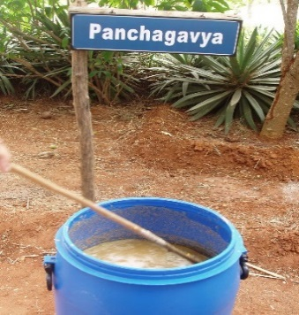
Application:
1. Take 1 lit of Panchagavya and dilutes it with 10 litres of water for spraying tree plantations and paddy fields etc.
2. Take 750 ml. Panchagavya and dilute it with 10 litres of water for all types of vegetables etc.
3. Apply once in 15 days.
NOTE:
- Panchagavya preparation varies from place to place
- The first five ingredients are mandatory, others are optional.

Contact persons:
- Shri.V.Ramakrishnan
Director and Project Investigator
Mob: 9442753975
Ph:04652 – 246296
E.mail:vknardep@gmail.com
www.vknardep.org;www.greenrameswaram.org

- Smt.S.Premalatha
Research Asst.
Ph:04652 – 246296
E.mail:vknardep@gmail.com
www.vknardep.org;www.greenrameswaram.org

