Technology category: Energy, lighting and fuel
Title: Tava stove designed for commercial and institutional kitchens
Year of development: 2011 - 12
Introduction: PYRO Tava stove
The value of the food vendor market in India is estimated to be Rs 816 billion. This dense and competitive market, requires fuel efficient technologies to save fuel costs, improve the working atmosphere for the cooks and extend their productive life span. There are three typical types of cooking practices in India – boiling, roasting and frying. The PYRO tava stove is designed to cook on a flat plate and is specifically designed for roasting rotis, kerala parottas, dosas, omelettes etc.
TIDE has developed biomass fired tava stoves for street food vendors that save 40% fuel over conventional stoves in three different sizes
Tava size 2 ft x3ft
Tava size 3ft x 4 ft
Tava size 2.5 ft x4 ft
Fuel used: Firewood at a burning rate of about 3 kgs/ / hr
Image:
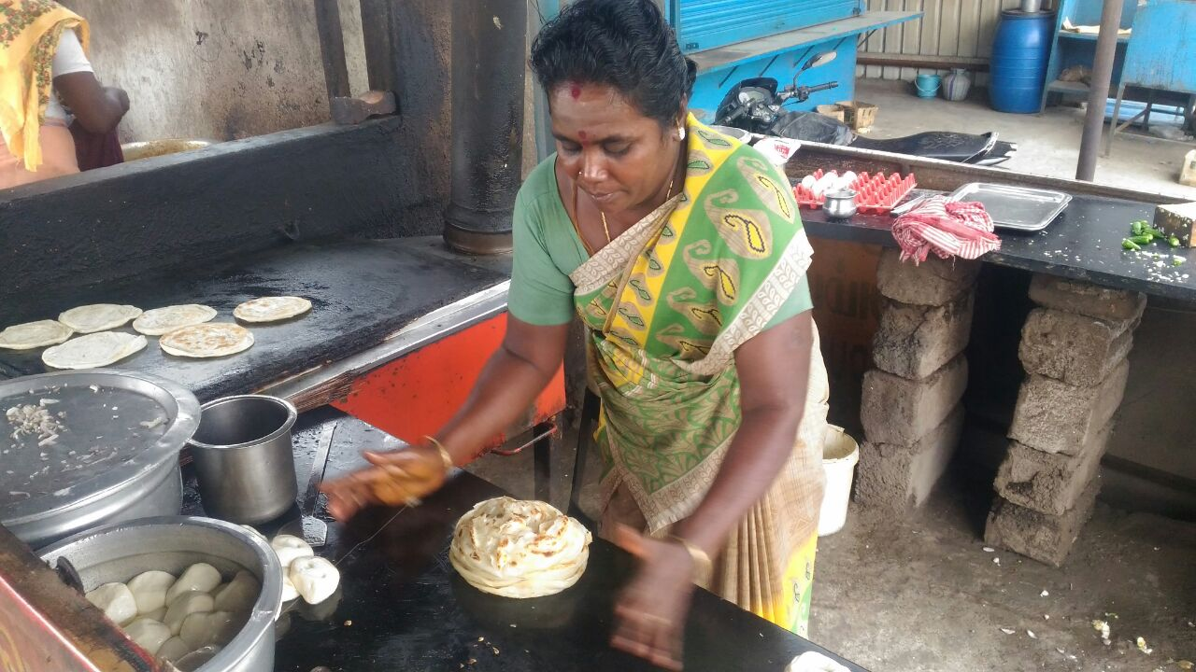
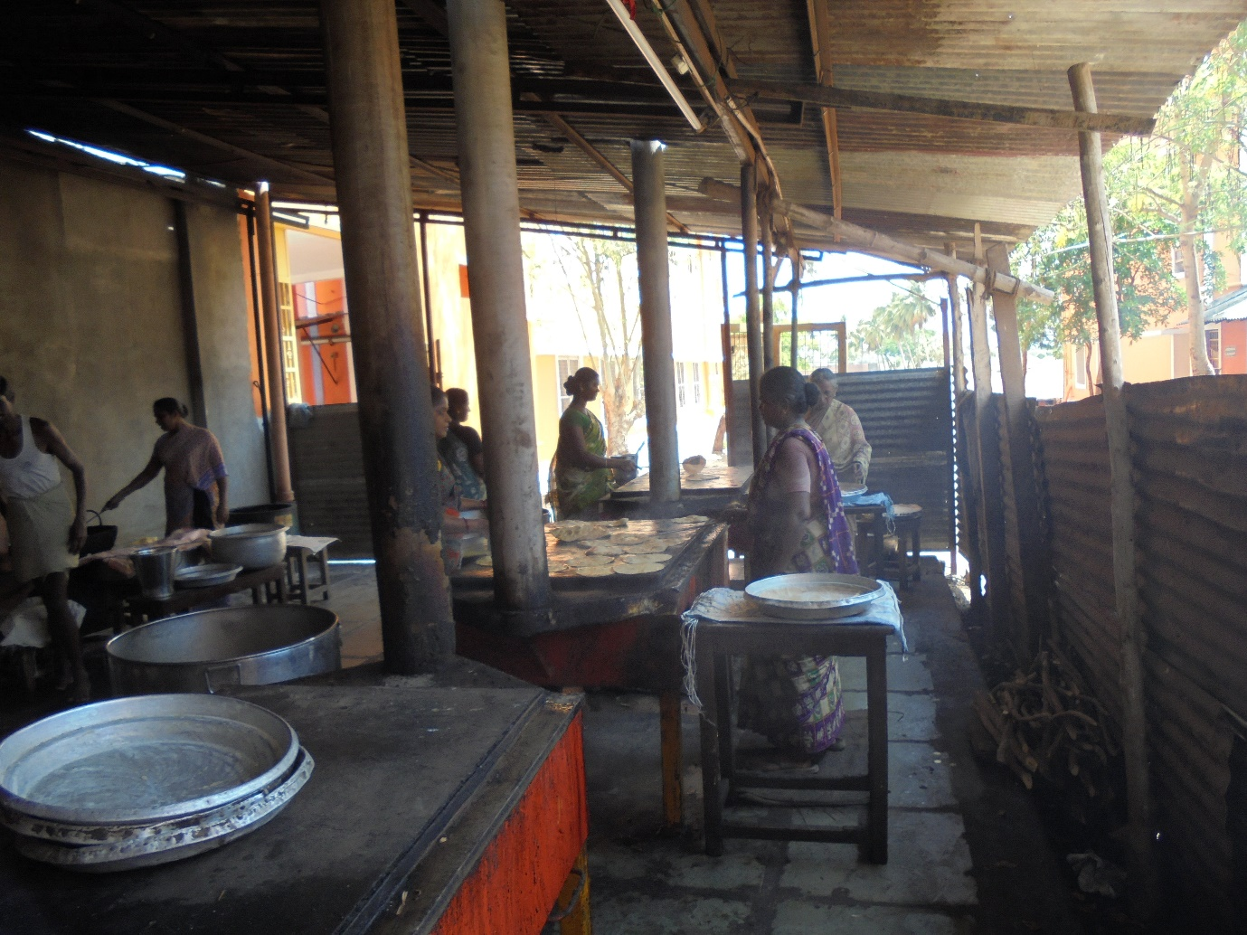
Developed by: Svati Bhogle and Velu for TIDE
Advantages:
- Fuel saving of 40% over conventional stoves and so reduces cooking cost.
- Durable life of stove-more than 5 years.
- Presence of air-vents to regulate fuel burning rate
- Lined with cold face insulation bricks to prevent heat loss
- *Available with chimney to expel release of smoke away from the cook and diners

Features:
- Designed for cooking on a flat plate
- Ideal for food items like dosa, parotta, omelette, pan cakes etc.
- Available in 3 different cooking capacities
- Long sticks of firewood, briquettes, coconut fronds or any woody biomass can be used as a fuel.
- Time taken for plate to reach cooking temperature 15-20min

Weight :110kgs

Current status: In active use by street food vendors in Karnataka, Kerala and Tamil Nadu, for making dosas and parottas. More than 1000 tavas purchased by street food vendors in the unsubsidized mode.

Links: https://www.youtube.com/watch?v=UqzHfSN9J2s

Concerned person: Svati Bhogle
Contact details: Technology Informatics Design Endeavour (TIDE)
Svati Bhogle 9845011380, svati.bhogle@tide-india.org
FF-1, Sapthagiri Apartments
No. 30, 10th Cross, 15th Main Road
RMV Extension, Sadashivanagar
Bangalore-560 080
Ph: 080 23612031 23612032
Mail: info@tide-india.org , tide.blr@gmail.com

