Technology category: Energy, lighting and fuel
Title: Attachments and accessories to improve convenience and extend life of PYRO stoves.
Year of development: 2016 - 2018
Introduction:
TIDE has also developed a range of attachments for its stoves. These are designed as inserts, add ons, spares to increase the life of the stove. The end user can thus have to option of replacing only some stove parts instead of changing the stoves. Some attachments developed are
Different options for an additional top plate insert to protect the top plate from corrosion and increase the life of the stove
- Roti puffing attachment for PYRO mini stoves
- Additional stands for greater stability of PYRO mini and chimney
- SS cladding for Tava stoves
- Replaceable sloping grate
- Insertable pre fab castable refractory insulation blocks for MP stoves
- Chimney caps and rain proofing tile for chimney
- Stackable mud blocks as chimney
- Power unit for the forced draft Agni Sakhi and Agni Mithra stoves.

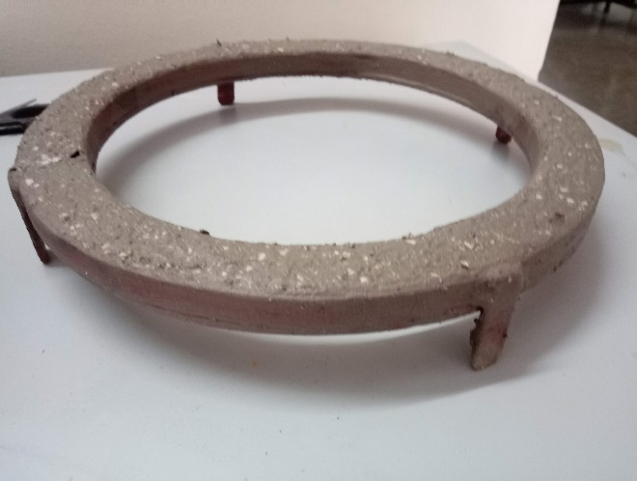
Image:
Insulated ring to prevent corrosion of top plate
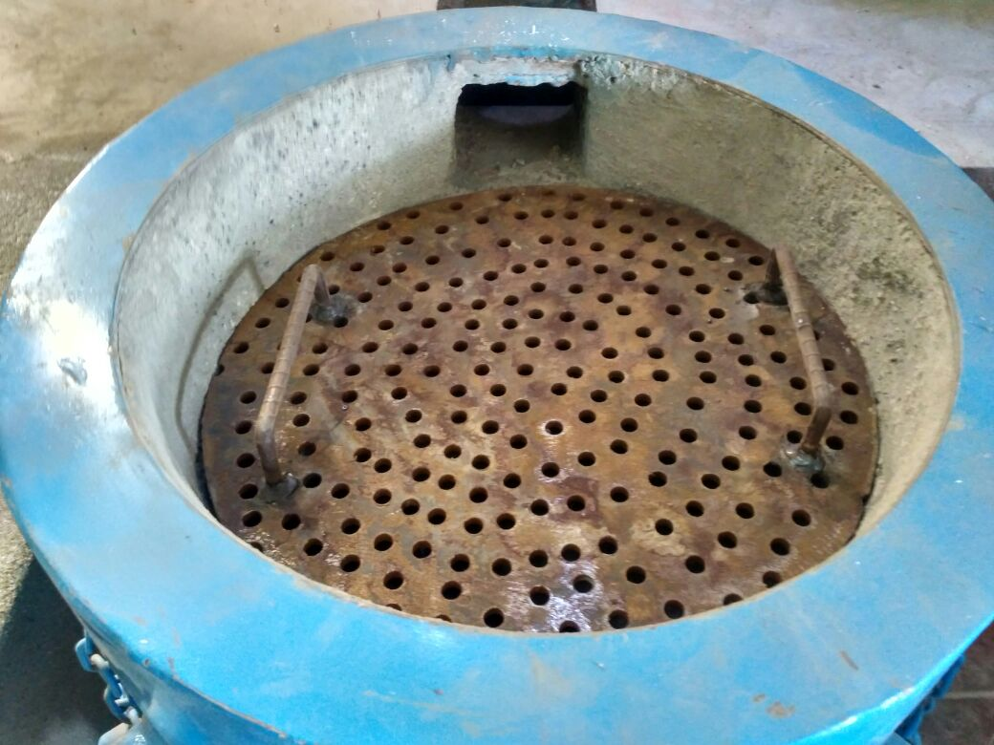
charcoal grate
Developed by: Svati Bhogle and Velu for TIDE
Advantages:
- Increases life of stove.
- Protects the cook from radiating heat
- Charcoal attachment makes the stove versatile and multi fuel
- Recommended for slow cooking applications
- SS cladding improves life of the stove, reduces corrosion and improves the good looks of the stove

Current status: Offered to stove users as an accessory at additional cost.

Concerned person: Ashiq Ahmed
Phone 8050432333, e-mail: ashiq.ahamed@tide-india.org
Contact details: Technology Informatics Design Endeavour (TIDE)
FF-1, Sapthagiri Apartments
No. 30, 10th Cross, 15th Main Road
RMV Extension, Sadashivanagar
Bangalore-560 080
Ph: 080 23612031 23612032
Mail: info@tide-india.org , tide.blr@gmail.com

