Technology category: Food processing
Title: Innovative women’s enterprises in biscuit making
Year of development: 2017-18
Introduction: Biscuits from finger millets
TIDE has developed a range of millet based biscuits. These include
- Relatively low cost finger millet and whole wheat biscuits with jaggery and margarine
- Healthier up market finger millet and whole wheat biscuits with jaggery and butter or coconut milk
- Mixed millet biscuits with jaggery and margarine or butter or coconut milk.
The baking temperature and the weight of the biscuits have been standardized keeping in mind taste and market needs

Image:
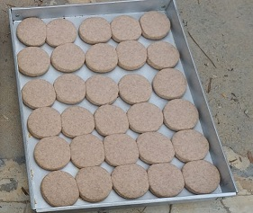

Enterprise model and recipes developed by: Sunil Patil / Manjunath
- Two different recipes (normal and premium developed at TIDE
- Backward and forward linkages developed with farmers and a Farmer Producer Organization
- Local markets developed through bakeries
- Premium markets developed through a buy back arrangement with the FPO.
- Ideal as a nutritious healthy food for anganwadis.

Current status: Biscuit making enterprise in operation by Manini self help group in TIDE’s WTP. Current order size 15,000 biscuits / month. The group now migrating from LPG fired oven to wood fired oven to improve profits.

Concerned person: Sunil Patil,
sunil.patil@tide-india.org
Contact details: Technology Informatics Design Endeavour (TIDE)
FF-1, Sapthagiri Apartments
No. 30, 10th Cross, 15th Main Road
RMV Extension, Sadashivanagar
Bangalore-560 080
Ph: 080 23612031 23612032
Mail: info@tide-india.org , tide.blr@gmail.com

