Concrete/Mortar Mixer Machine
The tradition concrete mixers are mostly used to RCC Column, Beam & Roof etc.

This small mixer machine very suitable for small scale building mixing cement mortar for Brick work & Plastering work

An also used small scale industry like Ventilator, Precast post, Water filter, FC Wall Pannels making etc.

We can provide the solution equipment of this field.

Dram Type Mobile Concrete/ Mortar Mixer Machine

The Feature:
1. Easy operation
2. Easy moving in and out at job site
3. Low maintenance
4. 220volts electrical power operating
5. Low investment cost of this mixer

Mixer Type - Dram type
Mixing Capacity – 1cft /batch (Normal) 1cft /batch (mix)
45.50/batch (Normal) 68.25 Kg/ batch (mix)
Elevating Speed
(Dram Revolution Speed) - 32~35 RPM
Required Motor - KW 0.37(H.P. 0.5)
RPM-1425
Volts- 220/240
AMPS- 5.0
Phase -1
Machine Weight - 80kg
PVC Dram
R-9’-4” , H-30”
BEARRING
MOTOR PULI
R-1”
STATER WHEEL
R-1”
MOTOR
0.5 HP , 1425 RPM
V-BELT
A-57
WHEEL
R-5”
PLY WHEEL
R-8.1”

Machine | 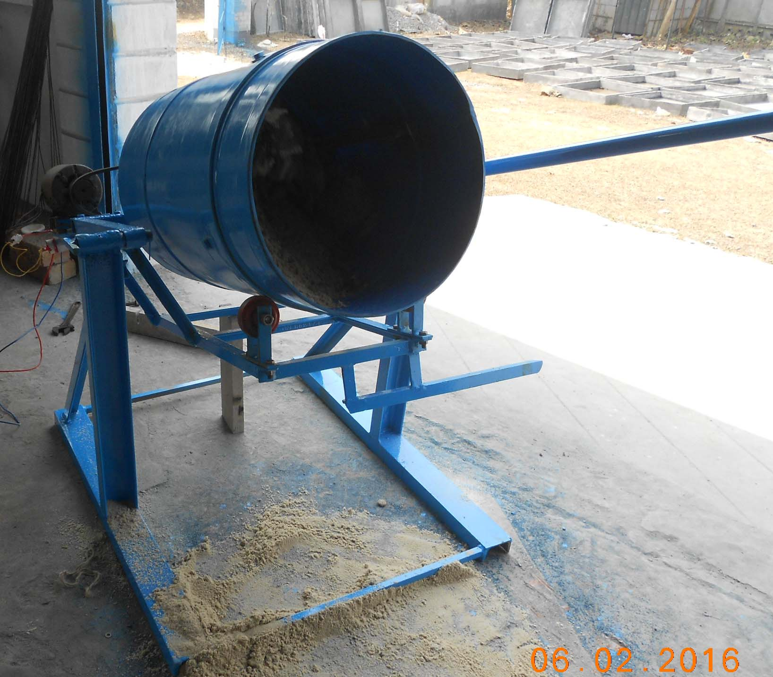
Dram  Size r-9”, h-30”  (120 liter.) |  |  | 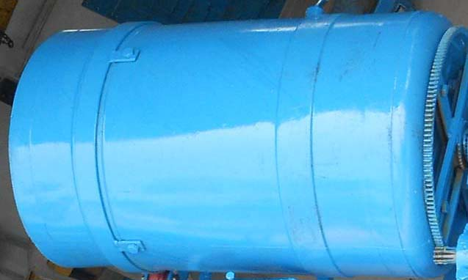
Motor- KW 0.37(H.P. 0.5),  1425 RPM,  Volts 220/240,  AMPS 5.0,  Phase 1. |  |  | 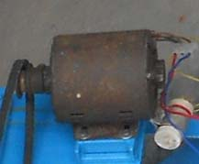
- Wheel r-8.5”  - Wheel r-5” |  |  | ` 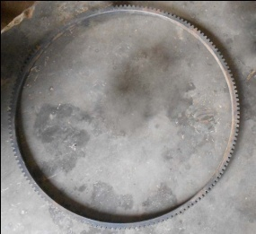
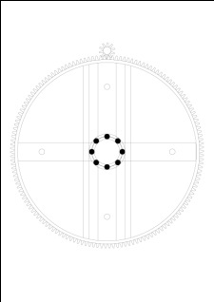 |  |  |  | 