Department of Science & Technology
Details of Technology Development & Transfer from DST supported Projects/Activities
Divison: SEED
Name of Scheme/Programme: CORE Project
Total Fund support by (i) DST: Partial (ii) Industry (if Any):None
Name & Address of PI/Co-PI: Dr. Sejal Worah (PI) and Ms. Vishaish Uppal (Co-PI)
WWF India, 172 B, Lodhi Estate, New Delhi - 110003

- Title of Technology / Product developed or underdevelopment process: Local adaptation of Fuel Efficient Devices
- Brief write-up (1/2 page):
Communities residing in and around the forests in the Terai regions of Uttarakhand, Uttar Pradesh and Bihar known as WWF-India’s Terai Arc landscape have been using traditional wood fired cookstoves for preparing meals and for heating water. They have been collecting fuel wood mostly from the nearby forests to fulfil this need. Consumption of fuelwood has increased due to a variety of factors including growth of population in the region and growing commercial demand for fuelwood as well. While in the forests collectors of fuelwood also run the risk of life threatening encounters with wildlife. The smoke from the traditional wood-fires stoves is harmful for the health especially for women and children due to prolonged exposure. While the Ujwala shceme is steadily making inroads in to rural areas, there continues to be demand for and extraction of fuelwood from the forests. To reduce the consumption of fuel wood and address the health hazard from smoke emission, a Fuel Efficient Cookstove model has been widely propagated. WWF India has particularly focused on adaptation and modification of the stove to render these suitable to the local context.
The Pyro-Mini developed by Technology Informatics Design Endeavour (TIDE) was selected by women in both Uttarakhand and Uttar Pradesh out of multiple stoves that they tested. However the Pyro Mini required several modifications to address the needs of the locals. These being:
- Local fabrication/ modification of chimney for removing smoke from cooking area and heating water
- Flexibility to use utensils of different sizes
- Design and development of a different device for easily making Chapati(roti)

- Details(including Photographs etc.)
The modifications/adaptations done to the existing model for local adaptations are as under:
Changes in chimney design:

- In order to prevent breakage of the cement chimney and minimize the bends as also to avoid breaking the wall, an attachment for fitting the chimney to the stove was modified.
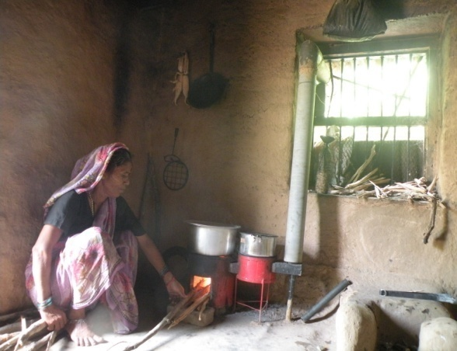
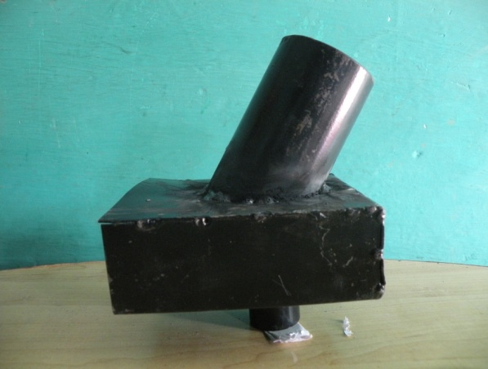

- A metal chimney was also tested. An attachment has been developed that also acts as water heating device and can be extremely useful in winter season when hot water is required. Initially the pilot was done with iron sheet but was later changed to GI sheet. The principle is to use the excess energy of the FEC unit to heat water. The use of water jacket increased the efficiency to 31%. The volume of water jacket is 17l approximately.

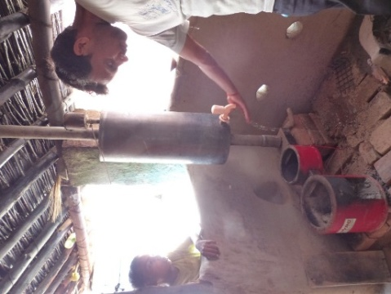

- Chimneys using bricks made of mud, husk and other locally available materials were designed on the advise of TIDE

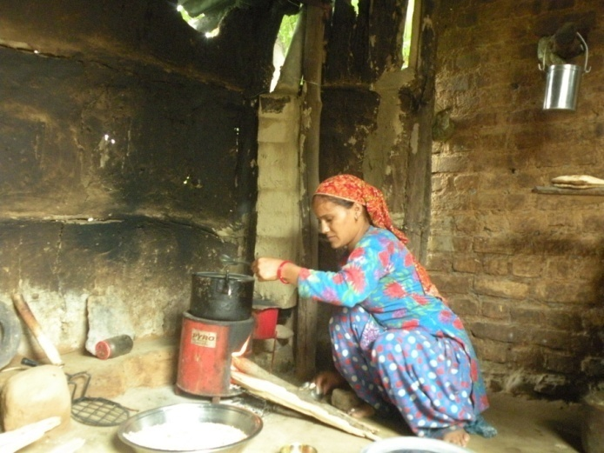
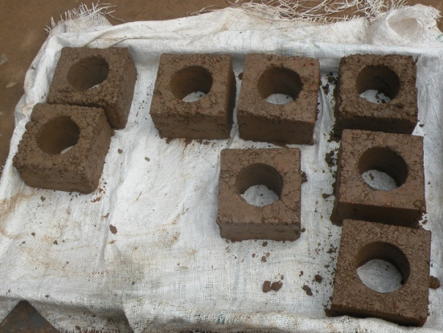
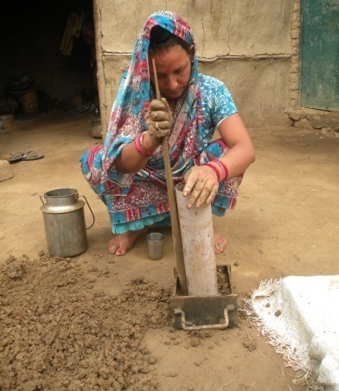
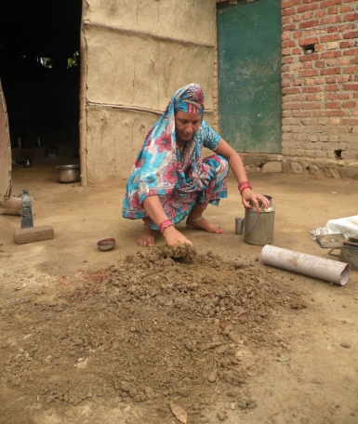

- Other modifications done included a metal frame of desired size to reduce the size of opening as per need and a roti puffer for facilitating cooking of roti.
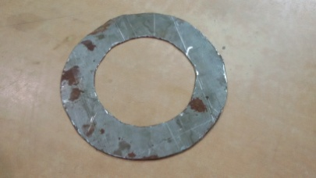
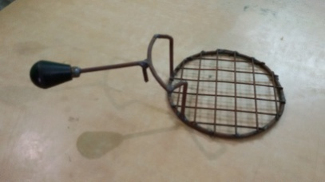
- Transferred to Industry (if Yes, Name & Address of the Industry):
No, this was mainly to promote and encourage local use
- Institutions/ Industries involved in the project:
WWF-India, Technology Informatics Design Endeavour (TIDE)
- Stage of development (Tech Transfer, Demonstration, field trial, etc.in next 6-12 months) Approximate Technology Readyness Level (TRL)

The technology has been tested in different locations WWF-India field sites in last two years along with needed modification has been done in regard to the users feedback regarding the same.

Regular feedback from the local communities is also feeding into the designs of stoves being prepared with the help of TIDE to make them more acceptable to the community.

- Further development required (If same group can do it or industry partner is required to get the product/technology in a final form suitable for commecialisation

Further development like - increasing the size of the pan opening, increasing the gap between the two pans etc. as suggested by the communities are being considered for modifications in original design without compromising the efficiency of the cookstove.

- Comparision with availalable technologies
A number of fuel efficient and smokeless model of cookstoves are present in the market. Tests were undertaken by the women in both Uttarakhand and Uttar Pradesh, four different fuel efficient stoves were tested including the Pyro Mini. The parameters on which these were evaluated were convenience of use, cooking efficiency in terms of time taken, efficiency in terms of fuelwood used and costs. The Pyro Mini was preferred by most of the women in both places.
- Approximate cost/ Economics (for the user e.g. buy-back period):
The different attachments of FEC ranges between Rs. 100 to Rs. 600. The water jacket costs around Rs. 600/-, the metal chimney costs Rs. 250/-, the cement chimney and its attachments cost around Rs.600/- and the chimney brick costing is around Rs.120 (Rs. 12 per brick). The cost of the stove itself being Rs. 3500/- plus taxes for catering to a household comprising 5-6 members.
- Contact Persons for further details:
Jishu Chakrborty: jchakraborty@wwfindia.net, 9759165987
Svati Bhogle: svati.bhogle@tide-india.org, 9845011380

