Department of Science & Technology
Details of Technology Development & Transfer from DST supported Projects/Activities
Divison: SEED
Name of Scheme/Programme: CORE
Total Fund support by (i) DST: Partial (ii) Industry (if Any): None
Name & Address of PI/Co-PI: Dr. Sejal Worah (PI) and Ms. Vishaish Uppal (Co-PI)
WWF India, 172 B, Lodhi Estate, New Delhi - 110003

- Title of Technology / Product developed or underdevelopment process: Forest fire management Equipments
- Brief write-up (1/2 page):
In India, about 55% of the forest area, which is predominantly covered by deciduous forests, is prone to fires every year, causing loss of about rupees 440 crores (~104 million US dollars) (Murthy et al, 2006). Of this 55%, 9.2% are affected by frequent fires whereas 45.5% by occasional fires (Source: FSI).
As per FSI’s State of Forest Report, 2015, 28.39% of 38000 sq. km of forest area has been identified as fire prone and classified as sensitive, moderately sensitive and highly sensitive based on the parameters such as aspect, forest type, forest cover, proximity from habitation and road, etc. (Forest Fire Mitigation Measures; a report by Information Technology and Geo-informatics Center and Uttarakhand Forest Department)
To support the State Forest Departments and local communities in managing forest fire, WWF- India has designed, fabricated and tested two units that can be used for forest fire management.
Unit - 1 is a common sprayer which is powered by a 50 cc engine (2 stroke) that can be used for for spraying water and lime and for blowing leaf litters. This helps in creating and cleaning fire lines in the forests. The weight of the device is 10 Kg . It has RPM of 6000 and air volume of 14 ft.
Unit – 2has also been designed and locally developed by WWF-India team, It , consists of a blower & cutter which can be used for cutting grasses, and bushes.
- Details(including Photographs etc.)
- The details of the units are mentioned below:
Product | Specifications |  | Out Put
Unit -1  Gasoline Power Operated life blower & water Sprayer | Displacement | 50 cc | - Lime Spray  - Water Spray  - Leaf/Air Blower
 | Engine Type | 2 Stroke
 | RPM | 6000
 | Fuel tank Capacity | 1.5 litter
 | Fuel Consumption | 500 ml /hr /(Petrol ( 40 ml/ 2T oil/ one litter )
 | Water tank | 14 litter
 | Rate Power | 1.2 Kg (1.6 HP)
 | weight | 10 Kg
 | Max Air Volume | 14 feet

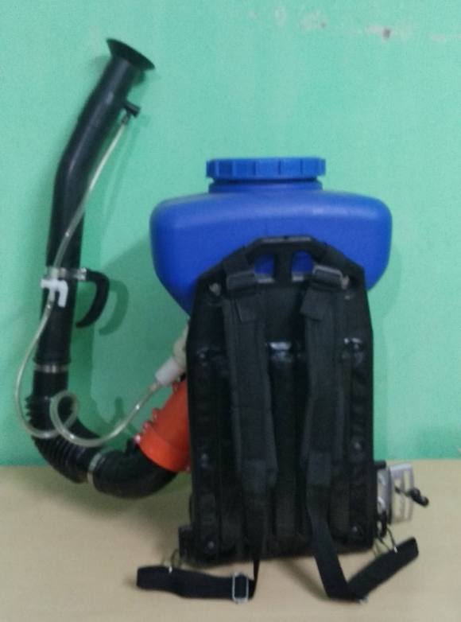
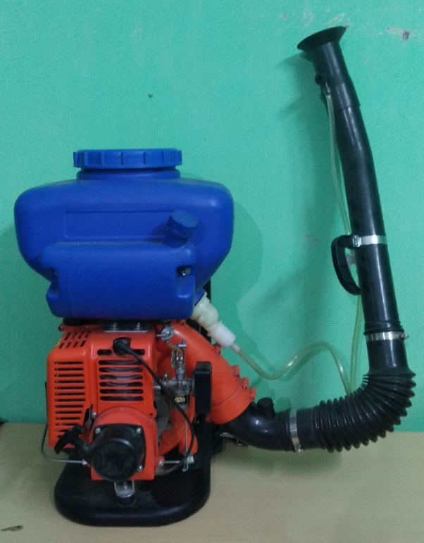

Product | Specifications |  | Out Put
Gasoline power operated Cutter with Air blower | Displacement | 52 cc | 1. Trimmer  2. Leaf/Air Blower  3. Light wood Cutter  4. Heavy wood Cutter
 | Engine Type | 2 Stroke
 | RPM | 7500-8000
 | Fuel Consumption | 650 ml/ hr
 | Fuel use | Petrol ( 40 ml/ 2T oil/ one litter )
 | Rated Power | 2.4 HP
 | weight | 9.5 Kg
 | Max Air Volume | 4 meter
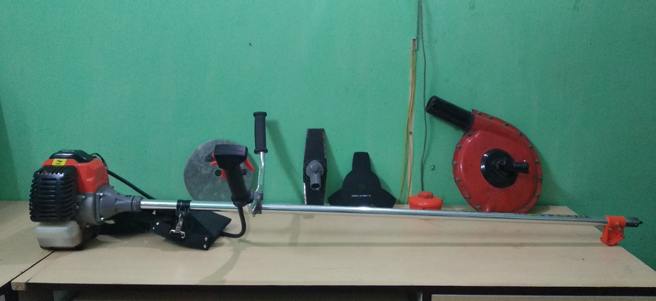
- Transferred to Industry (if Yes, Name & Address of the Industry):
NA
- Institutions/ Industries involved in the project:
The two units have been designed solely by WWF-India team. Experts and institutions will be contacted for advise.
- Stage of development (Tech Transfer, Demonstration, field trial, etc.in next 6-12 months) Approximate Technology Readyness Level (TRL)

The two units have been developed locally for forest fire management across the landscape. They have been tested for a brief period in 2018 during the forest-fire season (February-June) in the fringe of Pilibhit Tiger Reserve. The units will undergo further modification in design based on the observations and recommendations of experts.

- Further development required (If same group can do it or industry partner is required to get the product/technology in a final form suitable for commecialisation

The two units are in a preliminary stage and would need more testing for further analysis.

- Comparision with availalable technologies
NA
- Approximate cost/ Economics (for the user e.g. buy-back period):
The cost of the Unit 1 ( Sprayer and Blower) is Rs. 11,000/-
The cost of Unit 2 (Blower and Cutter) is Rs. 39,000/-
- Contact Persons for further details:
Mr. Naresh Lodhi and Mr. Jishu Chakrborty: jchakraborty@wwfindia.net, 9759165987

