Product development for low input soil/sand: Utilization of foundry waste slag and sand in building materials

Description
India’s foundry sector generates 10 lakh tonnes/annum with an annual growth rate of 1 lakh tonne. This amount of waste can occupy an area of 68.75 square km space with a depth of 1 meter. India’s generation of slag is predicted to multiply at an exponential rate of 10 lakh tonnes by the year 2020 which is equivalent to an area of 125 km² with 1 meter depth. The foundry slag utilization technology has led the benefits into two different industrial sectors. The first being the foundry owners who get a solution for the disposal of their foundry waste and the second are the paver block manufacturers who can avail quality aggregates at cheaper rate.
Development Alternatives Group, under Core Support Programme has developed a novel technology to use foundry slag in paver block manufacturing by replacing 100 percent of the natural aggregates by crushed slag. This meets the twin demands of resource efficiency and waste utilization. This crushed foundry slag is an ideal candidate for the replacement of natural aggregates due to its intrinsic properties close to natural aggregate. In the experimental study the effect of using foundry slag waste (FSW) as aggregate on the mechanical properties of the concrete based building products was investigated. Building products were produced using foundry slag, manufacturing sand and cement. It has been found that the use of foundry slag waste as coarse aggregate is both technically and economically feasible in M30 grade paving block making. The utilization of this waste provides an additional profit to the entrepreneur at the rate of 40 paisa per block.

Advantages
- Very high strength building products with 60% utilization of foundry slag waste
- Lower cost of production
- No extra capital investment
- Building products can be easily produced with the existing technologies
- Costs of the products around 10-15% cheaper than existing one

Current Status
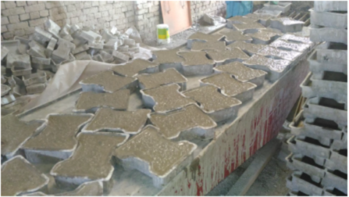
Total 10 sensitizing workshops were organized in different states of the country. Business models for foundry slag based paver block technology was developed for the entrepreneurs. Total 15 commercial enterprises were setup which are operating in a profitable manner. Samalkha cluster was declared as 100% waste free cluster.
Foundry waste based paver

Science for Equity Empowerment and Development Division
Department of Science & Technology
Ministry of Science & Technology, Tecnology Bhavan
New Delhi -16

