Department of Science & Technology
Details of Technology Development & Transfer from DST supported Projects/Activities
Division: SEED
Name of Scheme/Programme: DST-RC Core support project
Total Fund support by (i) DST: (ii) Industry (if Any): Nil
Name & Address of PI/Co-PI/ Contact person: Salma Alavi, Rural Communes,
70, 2nd floor LIC Building, Anandilal Poddar Marg,
Mumbai 400 002
Email: ruralcommunes@gmail.com
Title of Technology: Nutrient Rich Raised Bed Nurseries i.e. Mat nursery
Product Status: Field Tested and disseminated to small & marginal farmers of rural areas
- Brief write-up (1/2 page):
Producing young and robust seedlings is a challenge for rice farmers everywhere. Especially the farmers were finding it difficult to use machinery for transplanting crops like rice and ragi.

In order to produce young healthy saplings, a healthy nutrition rich soil bed is required which is called Mat nursery. Due to mat nursery farmers can produce healthy, young saplings which are uniform in size and easy to use in machinery. Currently due to mechanised agriculture the mat nursery becomes extremely helpful in transplanting the sapling to the main field, hence saving time and labour.

Requirements for a raised bed nursery are a layer of healthy soil mix arranged on a raised firm surface. It uses less land hence reduces management of time. It requires fewer seeds and inputs such as organic fertiliser and water. Overall it reduces nursery costs by up to 50%. After 8 to 12 days, the seedlings reach up to the two-leaf stage—which favors quick establishment in the field and rapid growth—and are ready for transplanting. This is much quicker than the 25–35 days required for traditional wet-bed nurseries. Raised Bed Nurseries are basically nutrient-rich and un-flooded raised nurseries

How to establish Nutrient-rich and un-flooded raised nursery:
- Use good-quality seeds for getting good result in terms of higher & more uniform germination, less replanting, fewer weeds, healthy seedlings and 5–20% higher yields.

- Soak the seeds in salt water for 12 hours then drain the water and keep the seeds moist by covering them for another 24 hours.

- Prepare the soil mixture i.e. mix 7 parts soil with 2 parts well-decomposed and dried cow & chicken manure, green manure, vermi compost and 1 part fresh or charred rice hull.

- Prepare the raised firm surface nursery area by increasing & raising the height of the soil by 4 to 6 inches. Level your seedbed and spread banana leaves or plastic sheeting on top to prevent the roots of the seedlings from penetrating into the soil.

- Lay the soil mixture. You can do this with or without using a wooden frame/bricks/bamboo or wooden sticks above the plastic sheets. For those using a wooden frame or frames (bricks, bamboo, wooden sticks, etc.) place the frame on top of the plastic sheets. The frame should be half a meter long, 0.3 meter wide, and 4 centimeters deep, divided into equal segments (or one small frame 12 x 12 inches). Smaller segments are required to facilitate transplanting the seedlings to the field without damaging the roots. Then, fill the frame almost to the top with the prepared soil mixture.

- Sow the pre-germinated seeds uniformly. Sprinkle soil and pat gently to embed them at about 2–3 centimeters into the soil, mulch with paddy straw and then sprinkle water immediately. Cover the nursery area with plastic sheets.

- Remove the wooden frame or sticks and repeat laying the soil mixture and sowing seeds until you have finished the whole nursery area.

- Water the nursery twice a day for 5 days and five days after seeding, remove the cover and continue to water twice a day.

- About 8 to 12 days after seeding transport them to the field, along with soil. A metal / bakelite (2 mm) / wood / aluminum (1 mm) boards could be used for lifting the seedlings along with soil and transplanting in the field, without any disturbance to the roots or about 20-24 days seedlings can be fed on the seedling trays of paddy transplanter and planted into the main field.

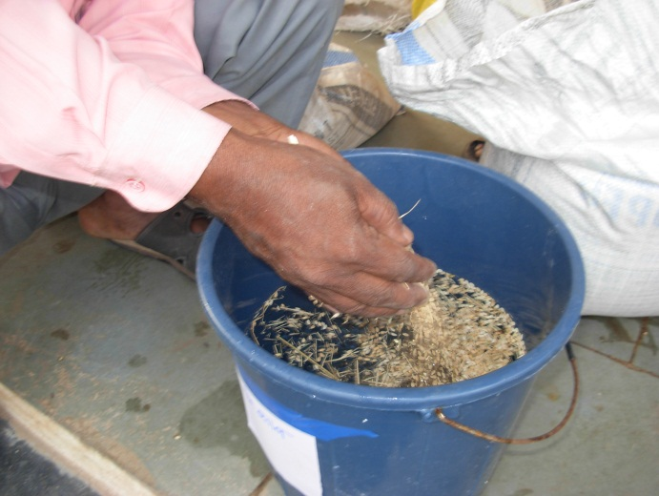  Keep seeds in salted water for 12 hours | 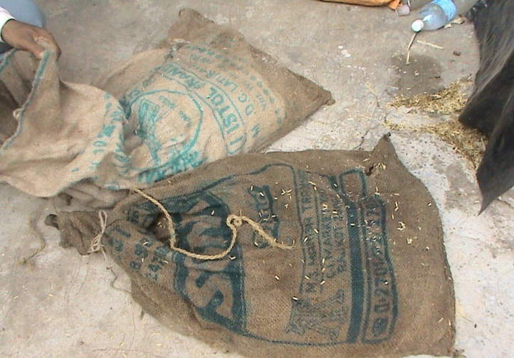  Keep seeds in Gunny bags for 24 hours after taking out from salted water
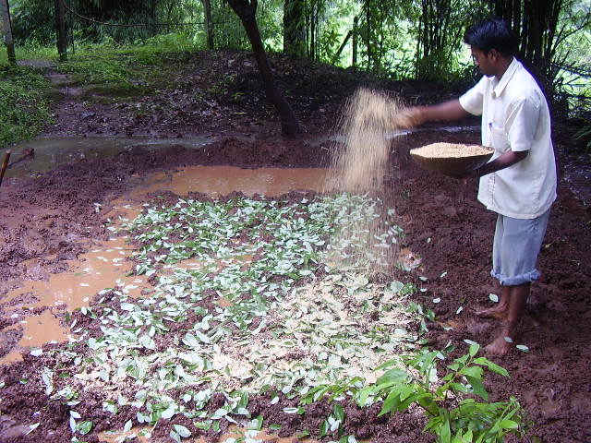  Preparation of organic soil mixture | 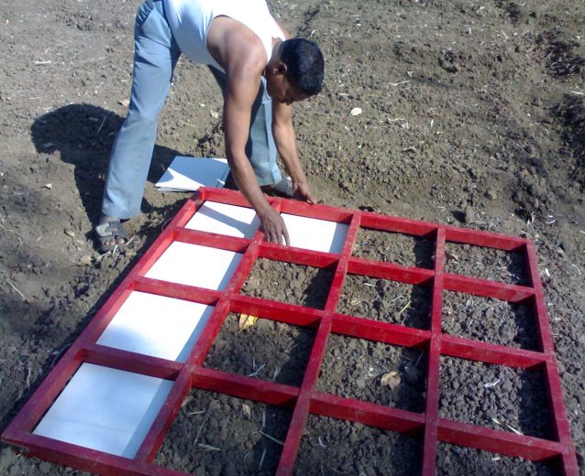  Wooden Frame and Putting GC sheets in Frame for the Mat nursery
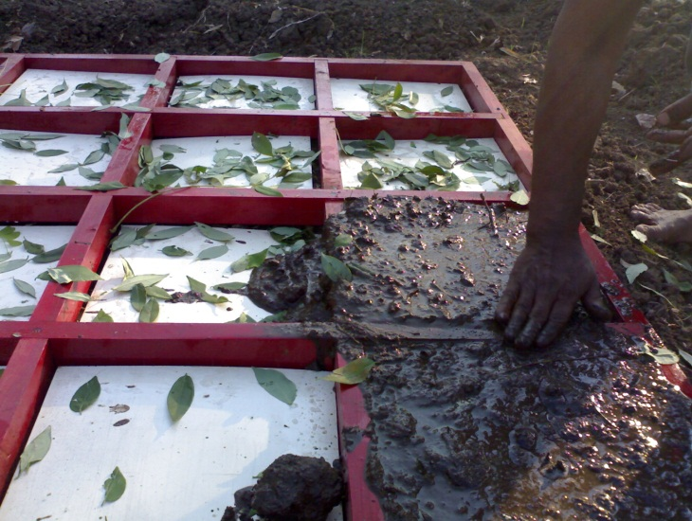  Putting Mixure of the organic manure in frame | 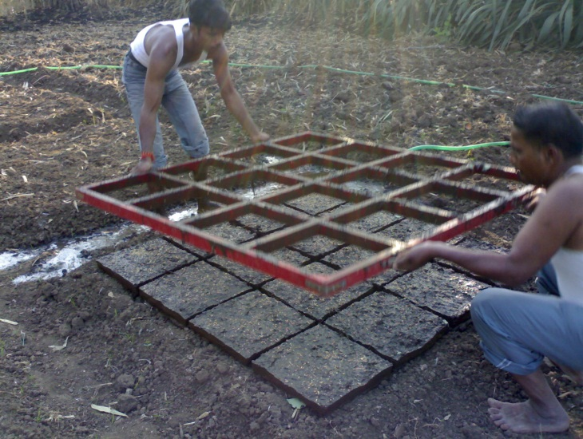  Removing wooden frame
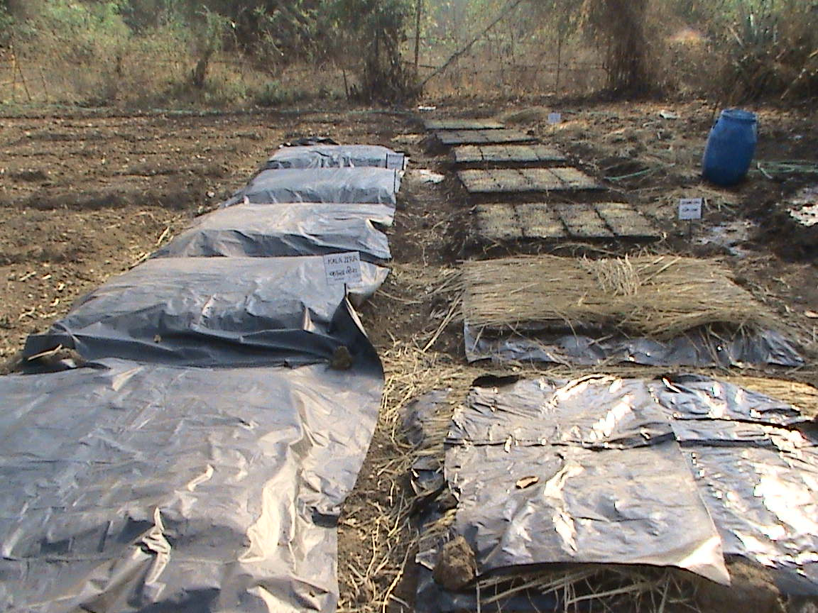  covered by dry grass & Plastic sheets | 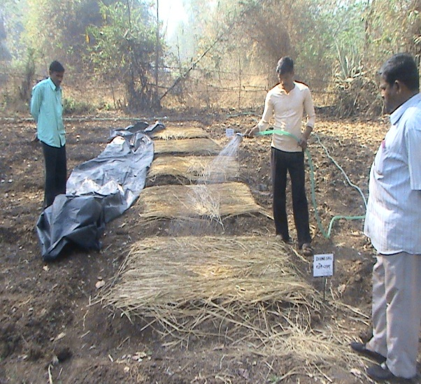  Watering the nursery
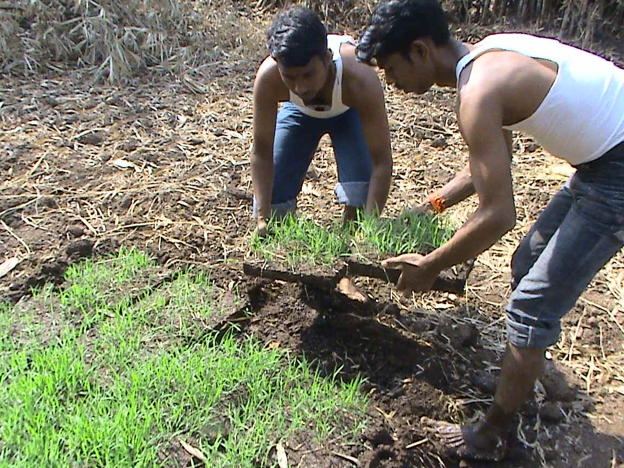  8 to 12 days seedling to transplant in the main field – manually | 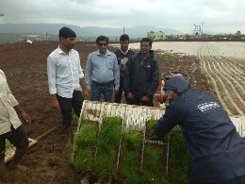  Transplanting through Mechanical Transplanter

- Transferred to Industry (if Yes, Name & Address of the Industry):
Technology has been developed and field tested by Rural Communes at our own Training Campus. After the successful demonstration this technology has been demonstrated and disseminated to small & marginal farmers and progressive farmers.

- Institutions/ Industries involved in the project:
With active support of Tata Power Community Development Trust, ICRISAT and SEED Division, Department of Science and Technology we are able to disseminate this innovative idea to the rural communities.

- Stage of development (Tech Transfer, Demonstration, field trial, etc.in next 6-12 months) Approximate Technology Readyness Level (TRL):TRL – Field tested, demonstrated and disseminated among small & marginal farmers and progressive farmers.

- Further development required (If same group can do it or industry partner is required to get the product/technology in a final form suitable for commercialisation:

No further development required as need based technology has been added and successfully demonstrated and disseminated to farmers by RC after the successful field trial.

- Comparison with available technologies:
The traditional nursery required more space and about 40 kg of seed needed to transplant into 1 hectare of area. Compared to traditional field nurseries, the nutrient rich raised bed nursery uses less land and it can be installed closer to the house. It uses less labour for land preparation, transporting seedling and transplanting. Root damage is minimal while separating seedling. Bed nurseries require fewer seeds and inputs such as fertiliser and water thereby reducing nursery costs by up to 50%. Most important is that the farmers save time and it is also environment friendly as soil burning (Rab practice) is not required.

The saplings from traditional nursery can be transplanted to the main field only manually but the sapling raised in nutrient rich raised bed nursery can be transplanted to the main field manually as well as by using mechanical transplanter. Mechanical transplanter transplants seedlings from mat type nursery in eight rows in a single pass and the cost of operation with the transplanter is Rs.3000/ha as compared to Rs.5000/ha by traditional method.

- Approximate cost/ Economics (for the user e.g. buy-back period):

- Contact Persons for further details:
Rural Communes
70, 2nd Floor, LIC Building
AnandilalPoddarMarg
Mumbai 400 002
Tel: 022-22085601 / 22050426
Email: ruralcommunes@gmail.com

