Enhanced Fish Amino technology
Plants need more than 20 nutrients. Starting from N.P.K, the major nutrients and ending with micro nutrients. On extensive action research carried out a Vivekananda Kendra for the last 15 years it is found that many compounds which are available the nature can influence the plant growth and the productivity substantially. The effect of Cow dung and urine based preparations like Panchagavya, Amirthapani etc., are well established. Literatures on animal waste Fish, meat, and egg based formulations are not available though it is established that there is a positive effect on the growth and productivity of the different crops.
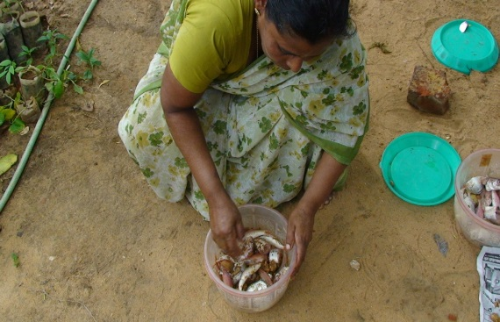
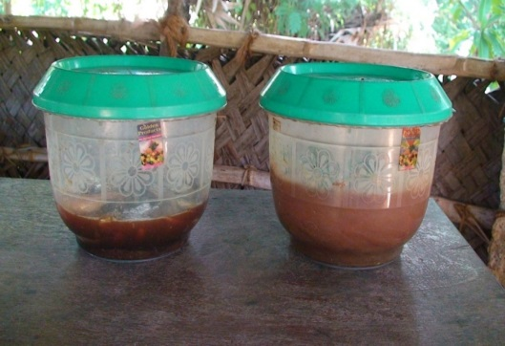
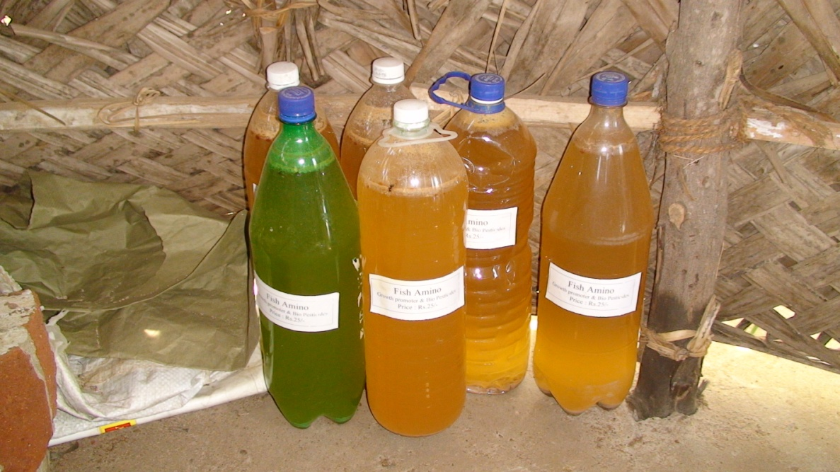
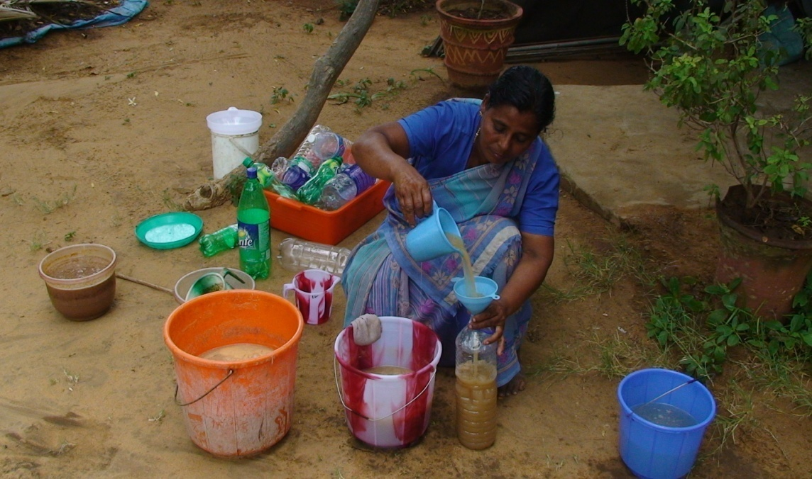
There is logic behind the effect of fish formulation as it contains rare essential amino acids, chelated calcium, prosperous, and a variety of other nutrients. These formulations if prepared scientifically are suitable for foliar spray which is 50 – 100 times more effective than soil application. The same compounds if applied in the soil as raw farm may not have much effective of the growth and productivity as major nutrients are lost in aerobic degradation.
Objective of the research work:
- To produce cost effective value added growth promoters and growth boosters from milk fish meat and egg waste.
- Study its efficacy in selected crops
Fish Amino Preparation:
During the post moon soon season huge quantity of fish waste and non-edible fish related waste is generated which offend become a disposal problem also results in environmental pollution and epidemics. Similar is the problem of fish processing units and big hotels. If this is properly processed in time, this will be a source of plant growth nutrients which will be cost effective. The fish waste either raw or processed will attractive microbes’ flies etc., as it contains rich proteins and cannot be kept beyond 24 hours as such. Microbial degradation with aerobes will putrefy it with foul smell which cannot be handled. A scientific and controlled fermentation can minimize foul smell and produce desirable products which can be handled and packed for future use as a plant growth promoter.
Controlled Fermentation:
There are different methods of fermentations depending on the quantity and status of fish waste. The technology is different for small scale and large scale.
Small scale fermentation:
This is suitable for fish waste up to 10 Kg
The first step is to prevent the growth of sulphur group of bacteria. This is mainly responsible for the breakdown of the sulphur containing protein and evolution of foul smell including hydrogen sulphide. The action of sulfur degrading bacteria can be prevented by adding equal quantity of jaggery or related products like molasses to the waste. This will promote the growth of micro-fungai like saccharomycetes. Which break down protein in to amino acids and carbohydrate in to alcohol and ketones. In this process the bones also get digested and degraded into phosphate and calcium compounds. Proper fermentation by a consortium of micro fungal and bacteria will complete the fermented within 15 – 20 days. The extract can be prepared by adding 2 – 5 times water in the fermented waste and filtered and be applied to plants preferably as a foliar spray. The undigested part if any can be used for soil application as manure.
The Science behind Fish Amino
Like animals plants also needs a varieties of amino acids which cannot be synthesised or may not be synthesised in sufficient quantity in plants. This is also the case of amines, organic ring compounds like indole compounds etc., which are very vital for vegetative growth, flowering and productivity. These compounds which are required in very small quantities becomes a limiting factor for the growth and the productivity of important crops.
Economics of Enhanced Fish-amino:
- Cost of 40 liter plastic can with cap - Rs.200.00
- Cost of 20kg rotten fish Rs.25 x 20* - Rs. 500.00 [free but money value given)
- Cost of 4 kg jaggery @ Rs.50 x 4 - Rs.200.00
- Pappaya latex 20 ml - Rs. 20.00 [free but money value given]
- Labour - Rs. 130.00
Fish amino yield of 25 litres cost - Rs. 1050.00
Per litre Fish amino is - Rs 42.00
The commercial equivalent is Rs 300.00 per litre of amino.
Per acre the amino need is 500 ml. So the farmer saves Rs 130 per spray. The farmer also has the possibility to market the Fish amino either individually or through collective efforts.

Contact Persons:
- Shri.V.Ramakrishnan
Director and Project Investigator
Mob: 9442753975
Ph:04652 – 246296
E.mail:vknardep@gmail.com
www.vknardep.org;www.greenrameswaram.org

- Smt.S.Premalatha
Research Asst.
Ph:04652 – 246296
E.mail:vknardep@gmail.com
www.vknardep.org;www.greenrameswaram.org

