Technology category: Energy, lighting and fuel
Title: PYRO multi purpose stove for commercial and institutional cooking
Year of development: 2012-13
Introduction: PYRO MP stove
The multi-purpose (MP) stove is a versatile stove designed to cook all kinds of food and meet needs of roasting, boiling and frying. It is designed in a range of sizes to cook meals, fry chips etc. It is ideal for big and small street food vendors, institutions, canteens, messes for sweet and snack makers especially in small towns and peri urban areas. PYRO MP stoves are designed for flat bottom vessels and frying pans with diameters from 40 cms to 99 cms.

Image:
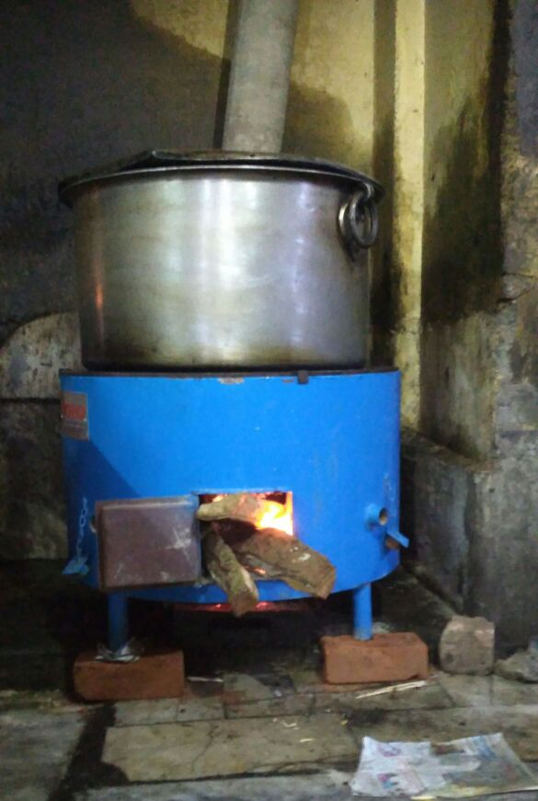
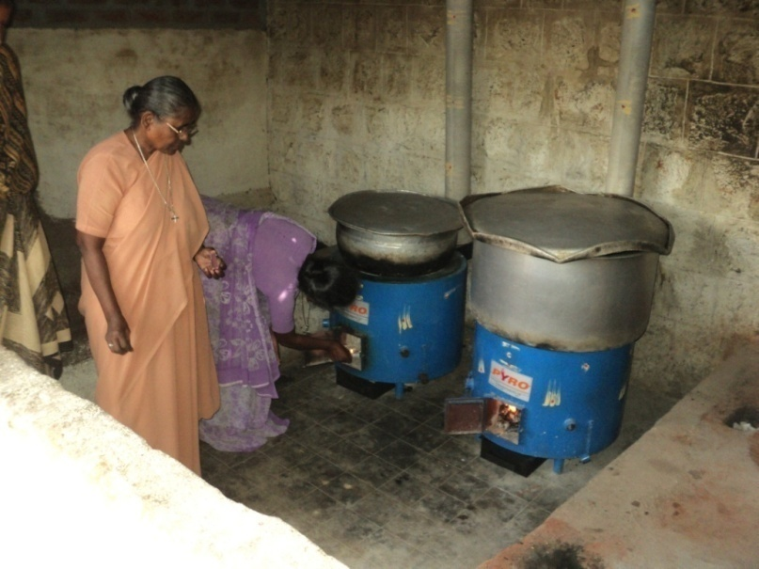

Developed by: Svati Bhogle and Velu for TIDE
Advantages:

- Fuel saving of 40% over conventional stoves and so reduces cooking cost.
- Burning rate 3 kg / hr
- Durable life of stove-more than 5 years
- Presence of air-vents to regulate fuel burning rate
- Lined with cold face insulation bricks to prevent heat loss
- Available with chimney to expel min.release of smoke away from the cook and diners

Features:
Suitable when cooking in a kadai, or any other vessel for deep frying, rice –cooking , curry making
Multipurpose/multifuel stove
*Can use firewood, briquettes and charcoal but with suitable attachments
* Available in 5 different cooking capacities for cooking 70-450 meals
*Versatile for preparing all types of food items, currys, sambhar, rasam, chicken, rice dishes, fried food etc.
Weight -44kgs

Current status: In active commercial use in Karnataka, Kerala, Andhra Pradesh and Tamil Nadu. Over 2500 stoves in the field.

Links: https://www.youtube.com/watch?v=EaotDfRhe_A

Concerned person: Svati Bhogle
Contact details: Technology Informatics Design Endeavour (TIDE)
Svati Bhogle 9845011380, svati.bhogle@tide-india.org
FF-1, Sapthagiri Apartments
No. 30, 10th Cross, 15th Main Road
RMV Extension, Sadashivanagar
Bangalore-560 080
Ph: 080 23612031 23612032
Mail: info@tide-india.org , tide.blr@gmail.com

