Technology category: Energy, lighting and fuel
Title: Loose biomass fired stove for commercial cooking.
Year of development: 2014
Introduction: PYRO Tava stove
With increasing biomass fuel prices, the trend among commercial kitchens is to shift to lower cost fuels like agricultural residues, saw dust, and carpentry wastes. The PYRO MSG stove is designed for institutional and commercial kitchens that use with loose, freely flowing fuels. The innovation is in the design of the sloping grate. This stove has also been developed for different combustion chamber volumes.
Image:
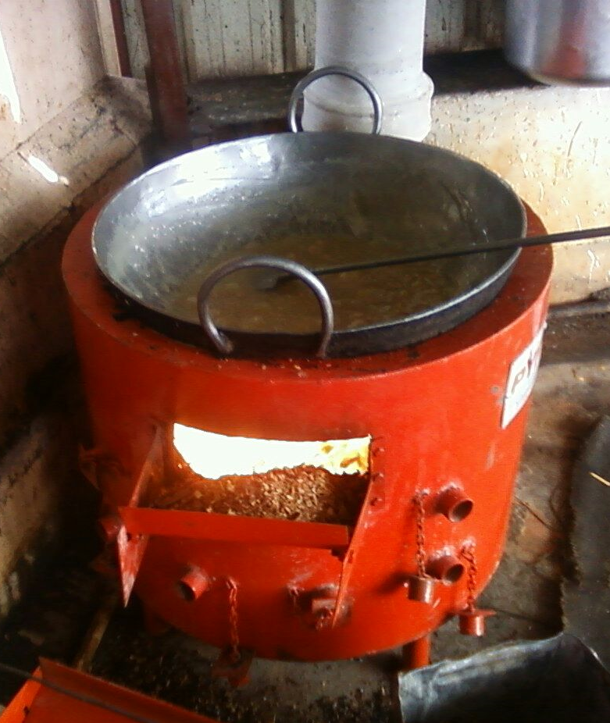

Developed by: Svati Bhogle and Velu for TIDE
Advantages:
- Fuel saving of 40% over conventional stoves and so reduces cooking cost.
- Durable life of stove-more than 5 years
- Presence of air-vents to regulate fuel burning rate
- Lined with cold face insulation bricks to prevent heat loss

Features
- Especially recommended for use in food processing units for deep frying of sweets and savouries
- Very versatile stove ideal for cooking meals also
- Uses low cost free flowing powdery fuel/loose bio-fuels like carpentry waste, cashew shells, ground nut husk etc.
- Mild steel stove body with provision of hopper for easy fuel feeding
- Recommended for heavy duty operation
- Innovative sloping grate for optimising air fuel mixing and to ensure complete and clean combustion of fuel

Current status: In active use by street food vendors in Karnataka, Kerala and Tamil Nadu, especially in food factories. More than 200 stoves in field.

Concerned person: Svati Bhogle
Contact details: Technology Informatics Design Endeavour (TIDE)
Svati Bhogle 9845011380, svati.bhogle@tide-india.org
FF-1, Sapthagiri Apartments
No. 30, 10th Cross, 15th Main Road
RMV Extension, Sadashivanagar
Bangalore-560 080
Ph: 080 23612031 23612032
Mail: info@tide-india.org , tide.blr@gmail.com

