Technology category: Energy, lighting and fuel
Title: Wood fired bakery oven.
Year of development: 2017-18
Introduction: PYRO Bakery oven
Baked products like cakes and biscuits are becoming popular in rural areas as ready to eat foods. Most small towns have shifted completely to electric or LPG fired ovens. The oven capacity is usually too high to meet the relatively lower demand in less dense small towns. TIDE has designed a bakery oven that is ideal for a woman’s home based enterprise. It can bake 100 biscuits per batch. A woman’s enterprise from TIDE’s WTP is making and selling biscuits in villages and small towns.
Image:
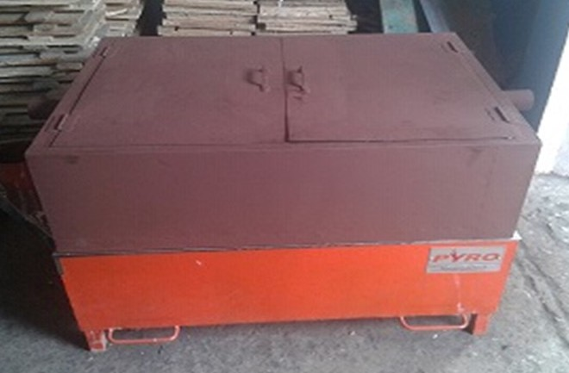

Developed by: Svati Bhogle / Ashiq Ahmed
Advantages:
- Designed to replace LPG and electric fire bakery ovens to reduce cost of baking and make them affordable for a rural baking enterprise.
- Provides energy security for baking.

Features
- Optimized baking chamber dimensions to reduce the cost of cooking and maximize weight of baked food.
- Two trays can be loaded at a time
- Ideal for new rural livelihood option: village level bakery enterprise
- Designed for 96 large biscuits in a single firing
- Long sticks of firewood, briquettes, coconut fronds or any woody biomass can be used as a fuel.
- Time for baking biscuits made from mixed and finger millets is just 8-10 min

Current status: Under field testing.

Concerned person: Ashiq Ahmed
Contact details: Technology Informatics Design Endeavour (TIDE)
Ashiq phone 8050432333, email - ashiq.ahamed@tide-india.org
FF-1, Sapthagiri Apartments
No. 30, 10th Cross, 15th Main Road
RMV Extension, Sadashivanagar
Bangalore-560 080
Ph: 080 23612031 23612032
Mail: info@tide-india.org , tide.blr@gmail.com

